Create VPC with 2 private and 2 public subnets

First go to vpc and create a new vpc
In pv4 range I gave CIDR 24
Then created a vpc

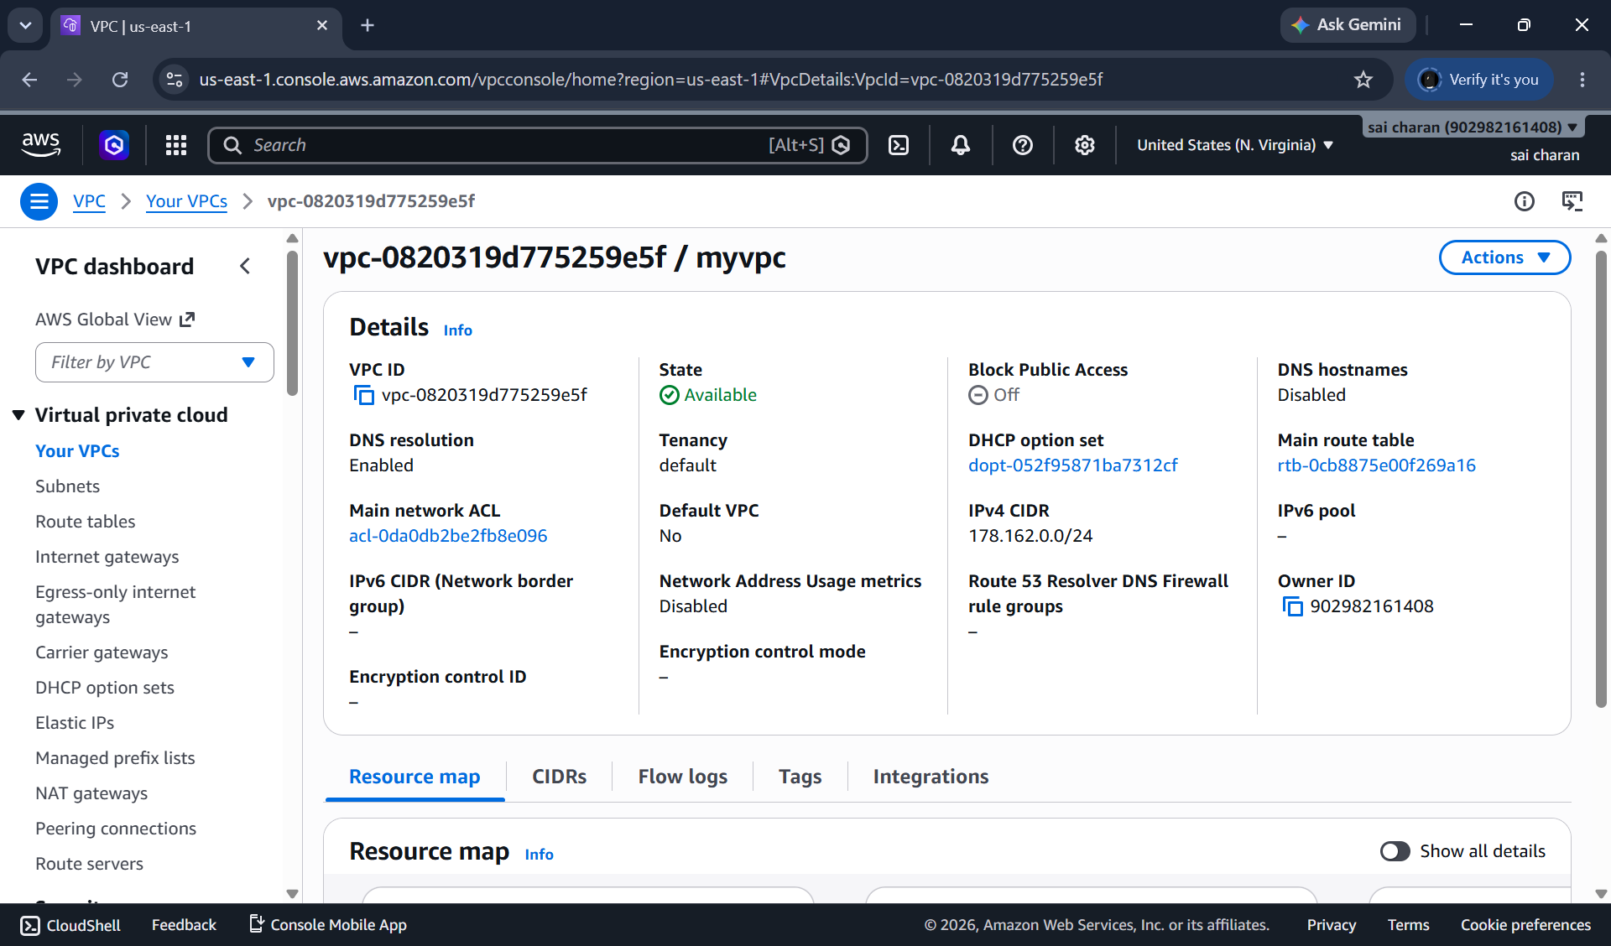

Created a new subnet and cldr 28 and the subnet ip should be b/w 16 ips
And I have created a 2 new subnets b/w 32 available address

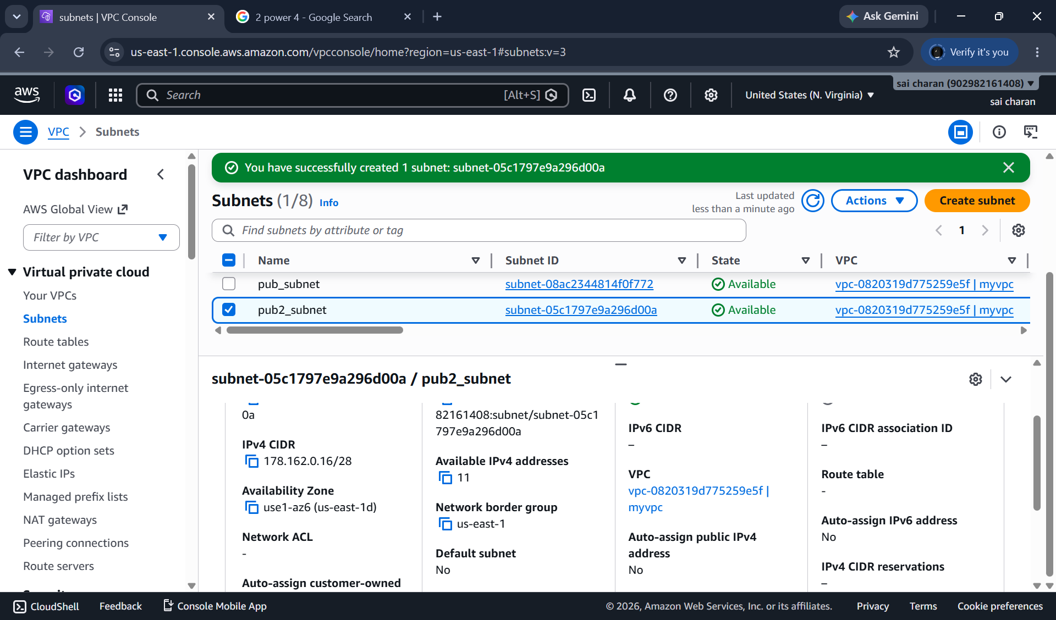
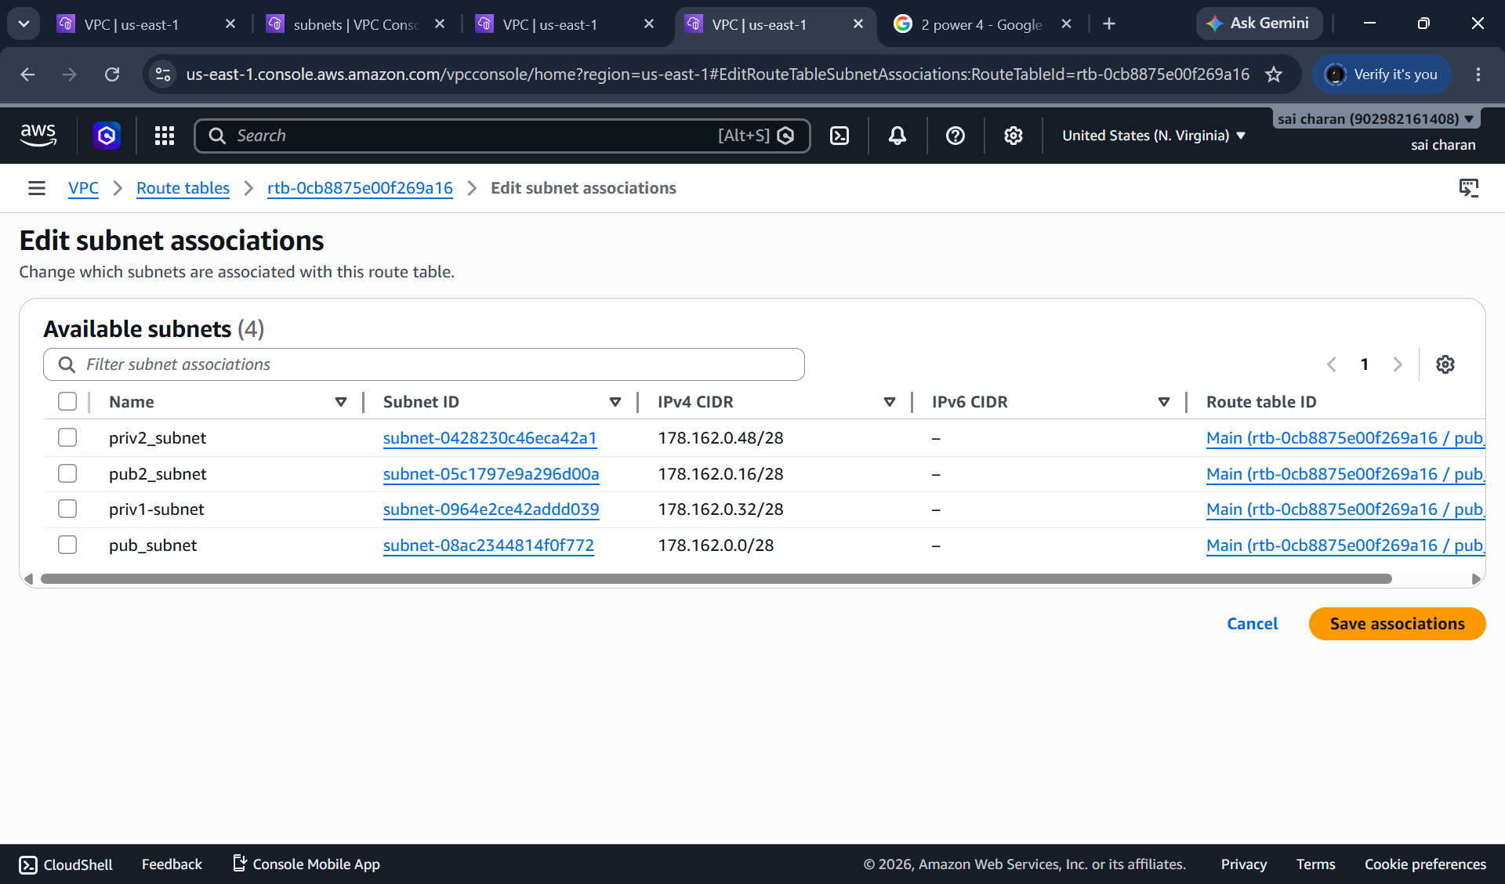
Here I have created 4 subnets pub and pri
I will be allocating pub-sub to pub rt and priv_sub to pri-rt

Here pub rt has internetgateway and priv subnet doesnot have igw
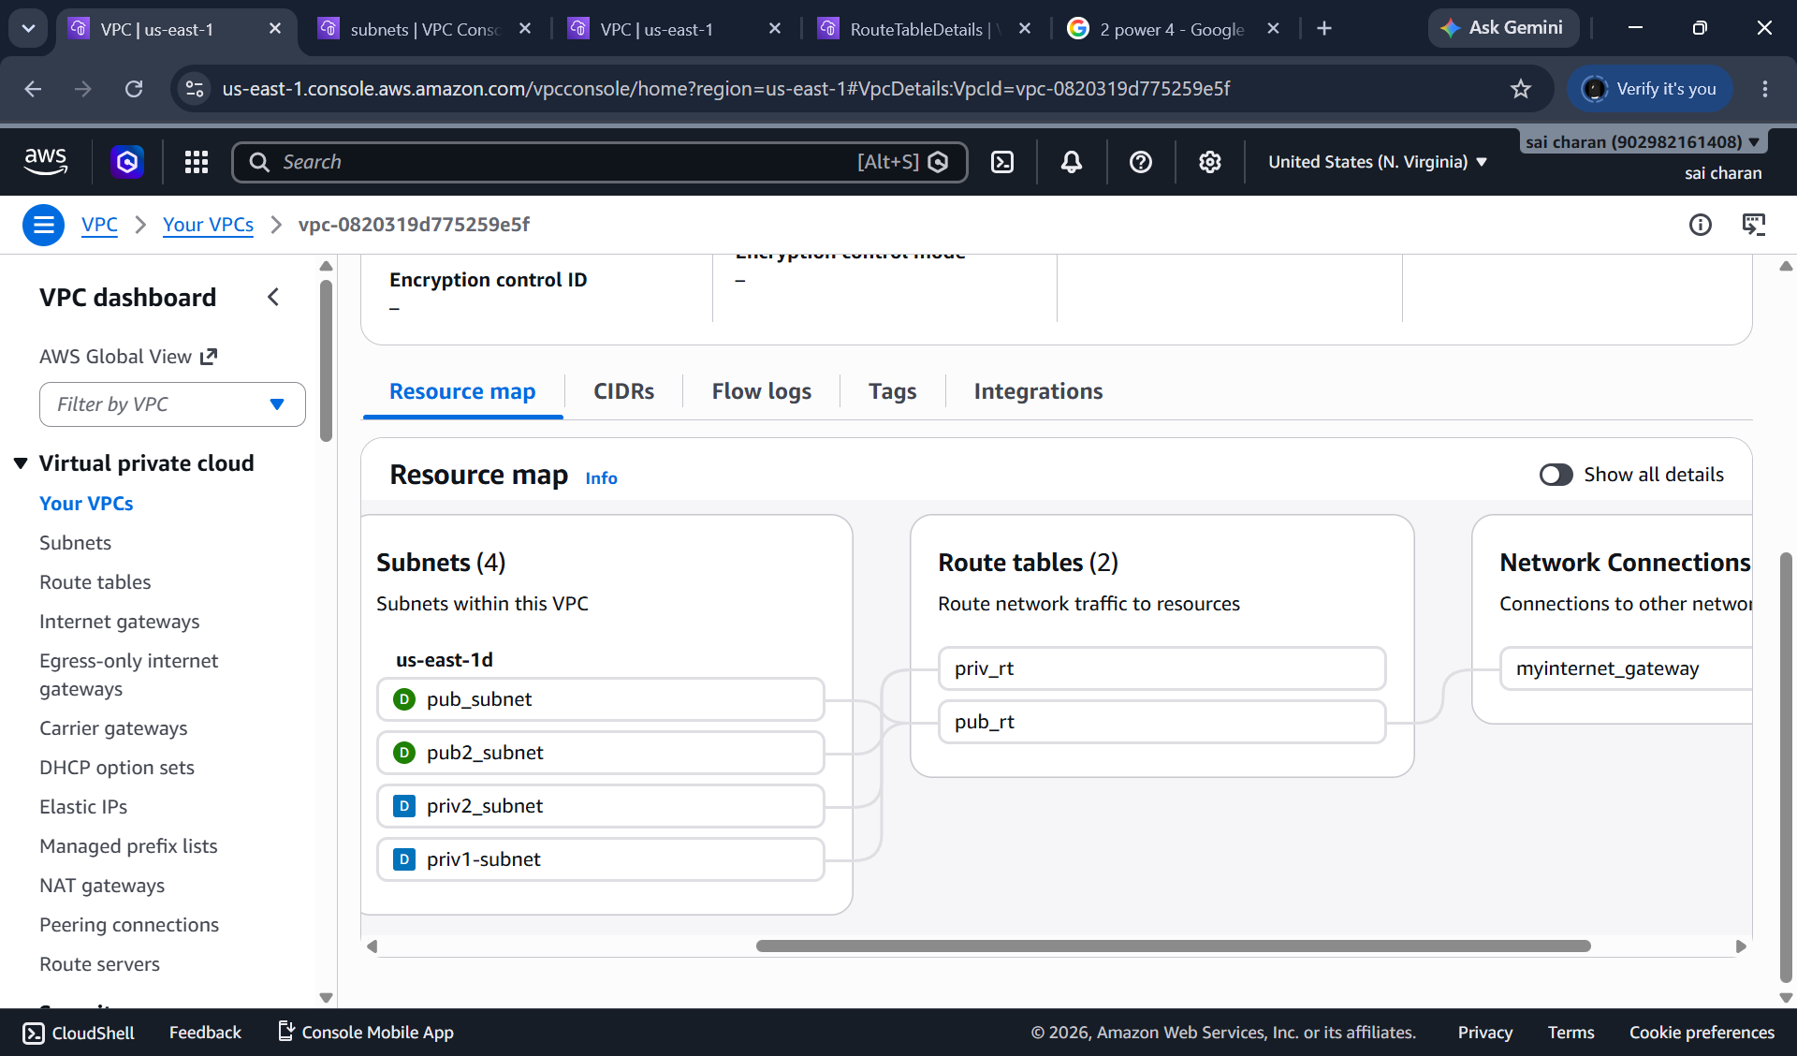

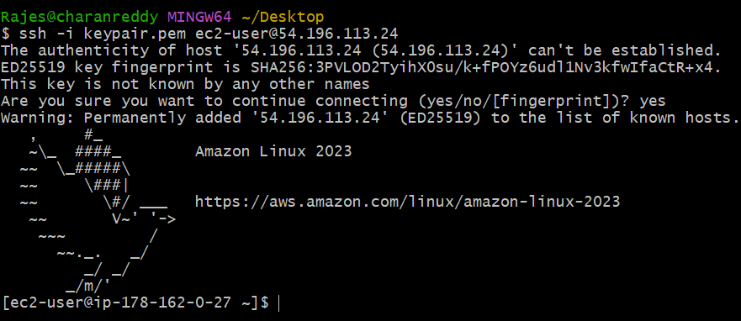

Now I have internet access to pub subnet
If I connect with my priv subnet then I wont be having internet access
Because internet gateway is not mentioned inroute table for priv subnet

Enable DNS Hostname in VPC

To enable dns hostname I need change settings for my vpc
Go to vpc settings and enable dns hostname

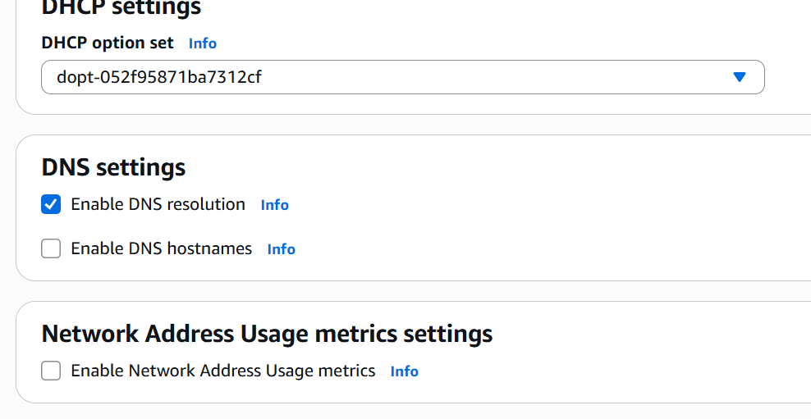
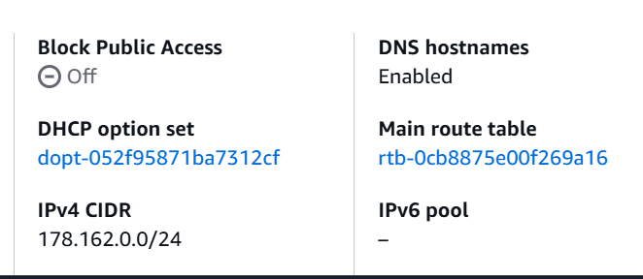

Enable Auto Assign Public IP in 2 public subnets

To enable auto assign public ip for public subnets
Go to subnets click on public subnet
Got to edit subnet settings
Then enable auto assign ipv4 address

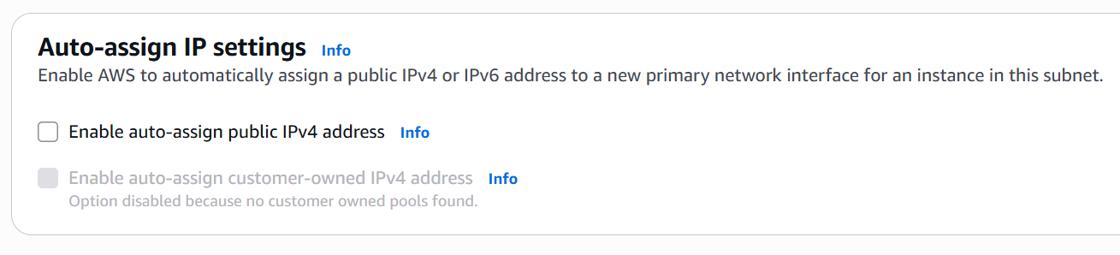

Add 2 private subnets in private route table

Go to route table
Then create a new route table naming private route table
Then under go to subnet associations and select the priv subnet from options
Then the pri _subnets we created earlier will be added to private route table
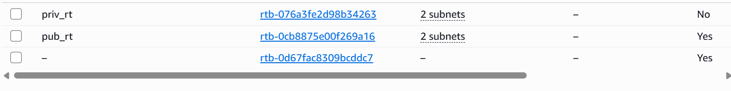

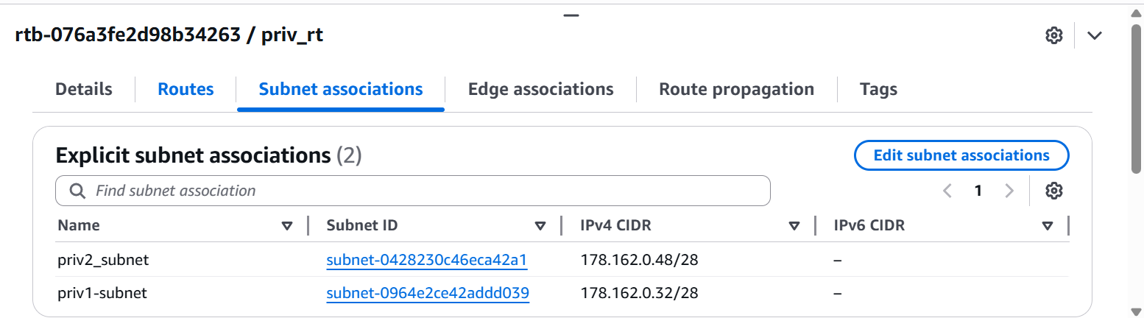
We can see pri_subnets has been added

Add 2 public subnets in public route table

Go to route table
‘create a new RT naming pub_rt
Then go to subnet associations
From there select public -subnets and
Now the pub subnets has been added to public route table

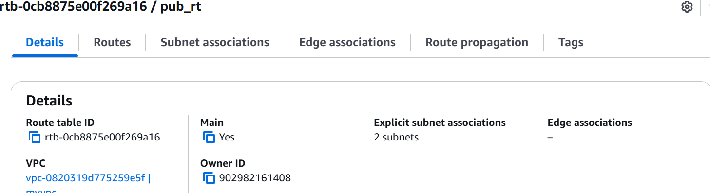

Then after adding subnets allow route for public route table
Because public subnet and publci rt has internet gateway
By this we can access internet or connect to the server 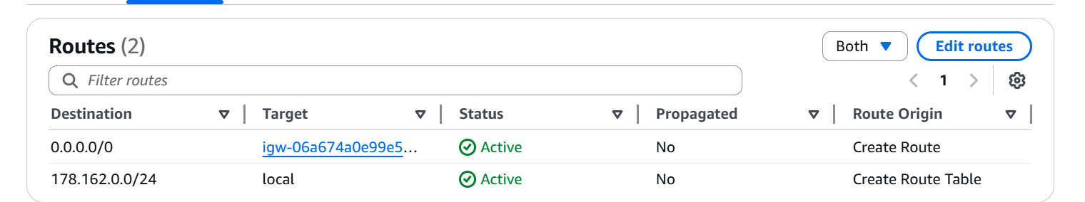

Public route table will have the routes to internet and local

We should give internet gateway access and allow the internetgateway route to access to the internet for public subnet and public route table

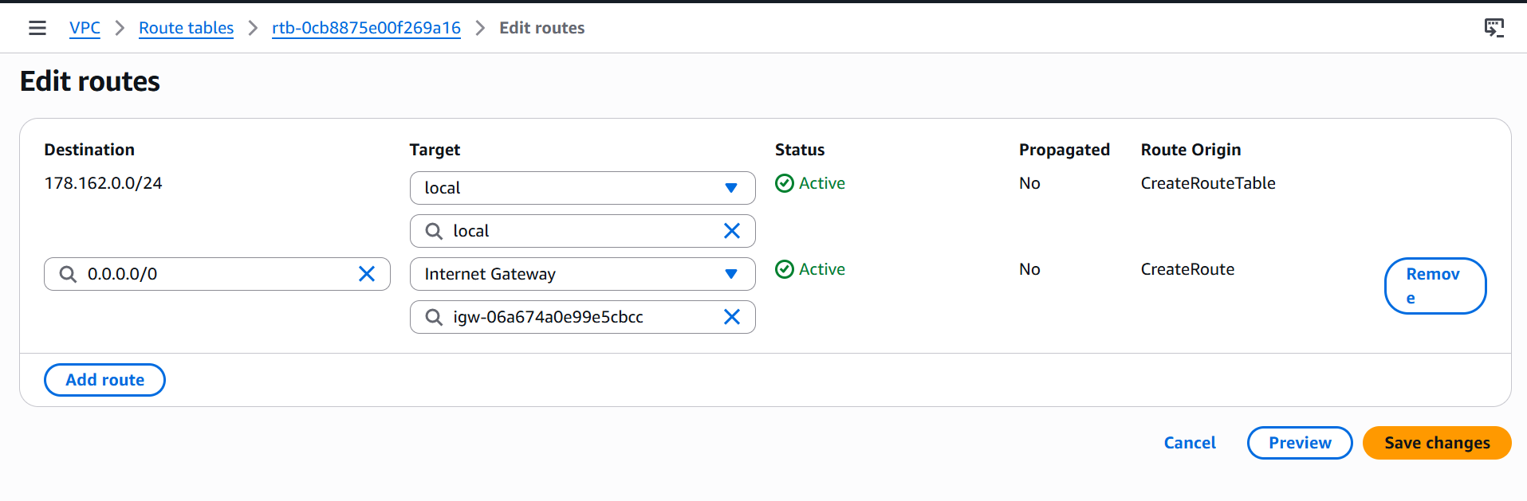
As we can see I have allowed the internet gateway that I have created earlier for internet access to the public subnet and allowed the route to the ec2 for internet

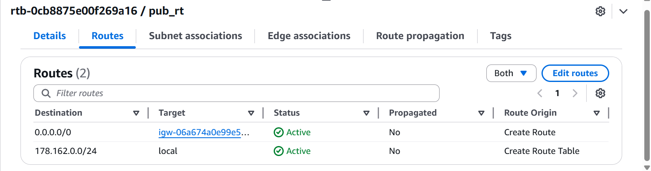

Create EC2 in public subnet with t2.micro and install PH

I will be launching a new instance and giving my public subnet that I have configured before

I have created a new instance
And I will select my custom vpc that I have configured with pub subnet
And I will be installing a php in user-data
In advanced settings
#!/bin/bash
apt-get update -y
apt-get install -y apache2 php libapache2-mod-php
systemctl start apache2
systemctl enable apache2
echo "<?php phpinfo(); ?>" > /var/www/html/index.php

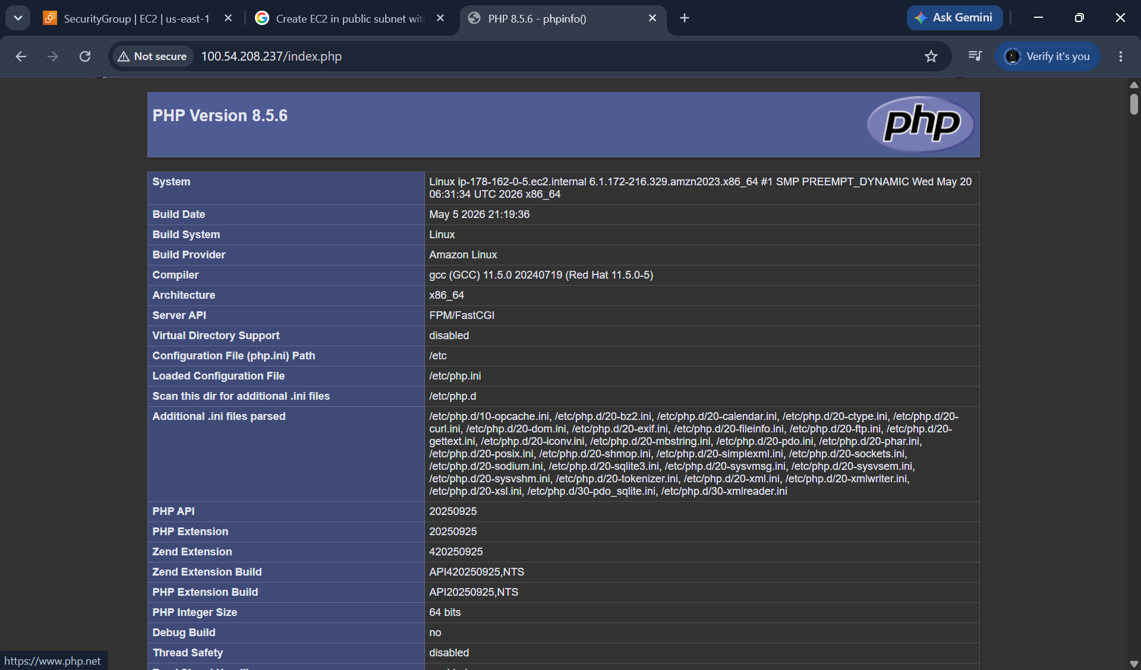

Configure NAT gateway in public subnet and connect to private instance

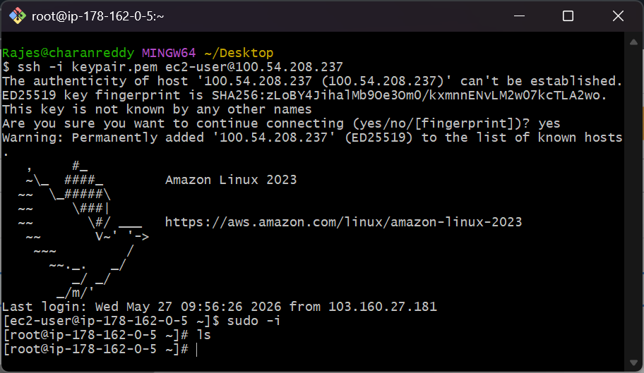
This is my public instance which has internet access through internet gateway

Now I will be launching a private instance with pri subnet which don’t have an internet access
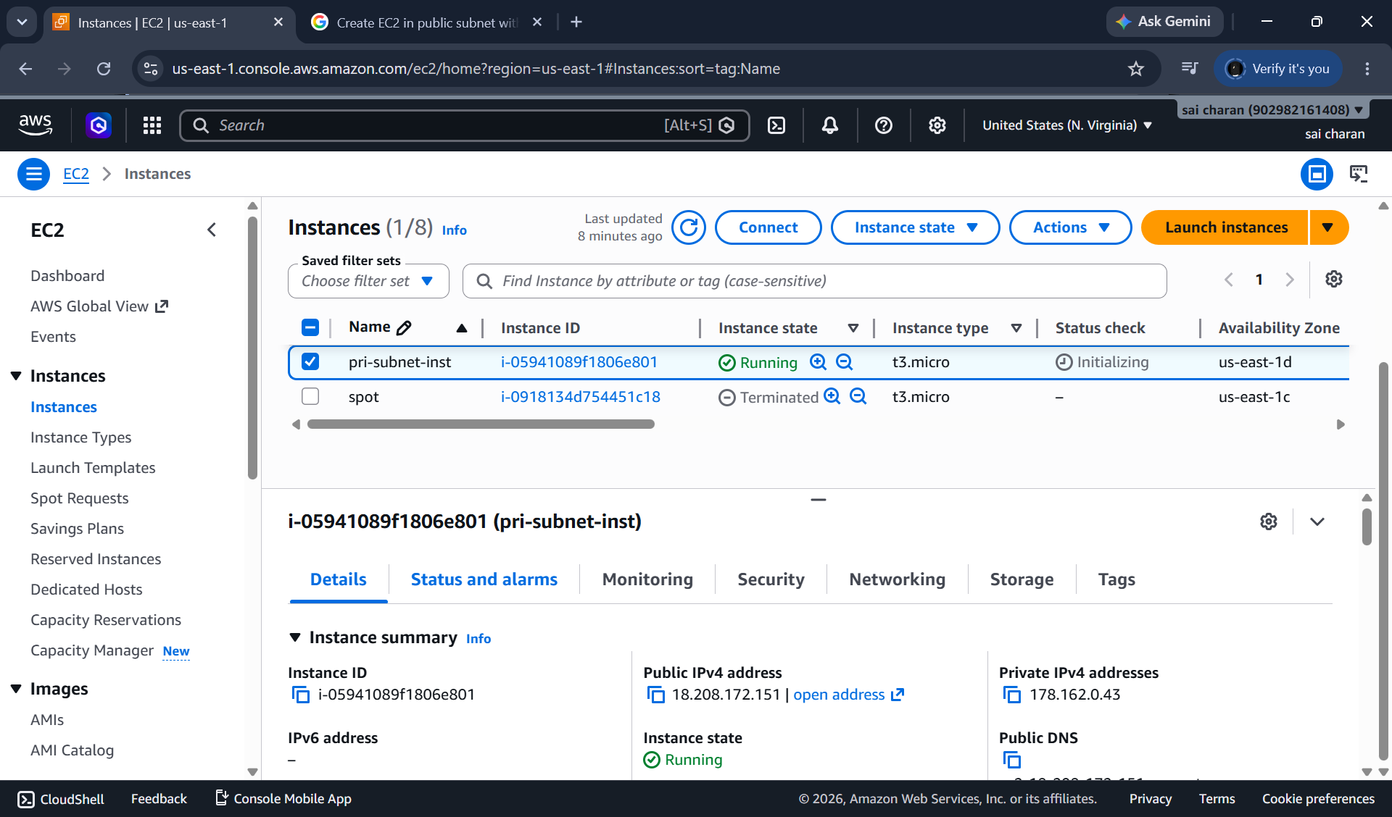
In below ss we can see the connection has been timed out because it has private subnet that has no internet gateway access configure fo pri sub-net
So now If I want to access priv instance without giving the internet gateway I will connecting through jump server that is pub instance
And to establish connection for internet oneway to private instance I will giving NAT GATEWAY to public so that I can access my priv instance from public instance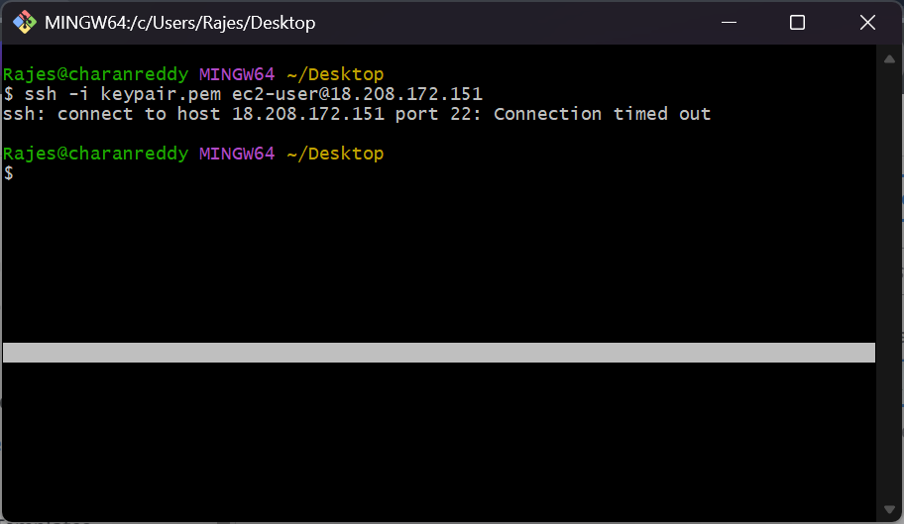

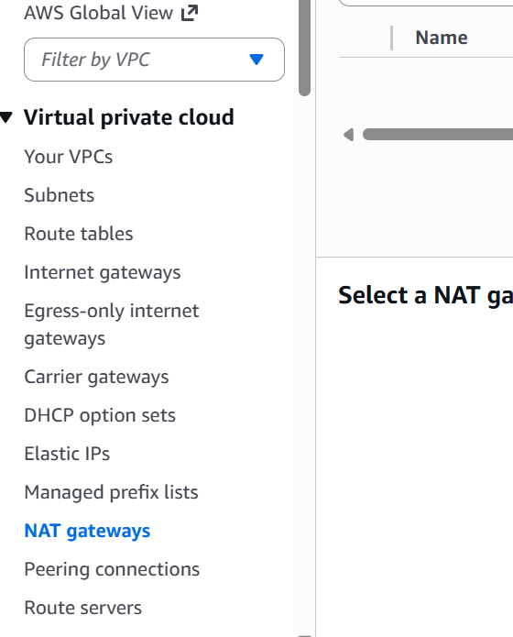

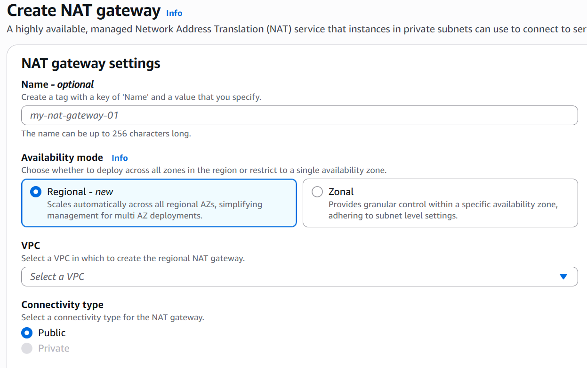

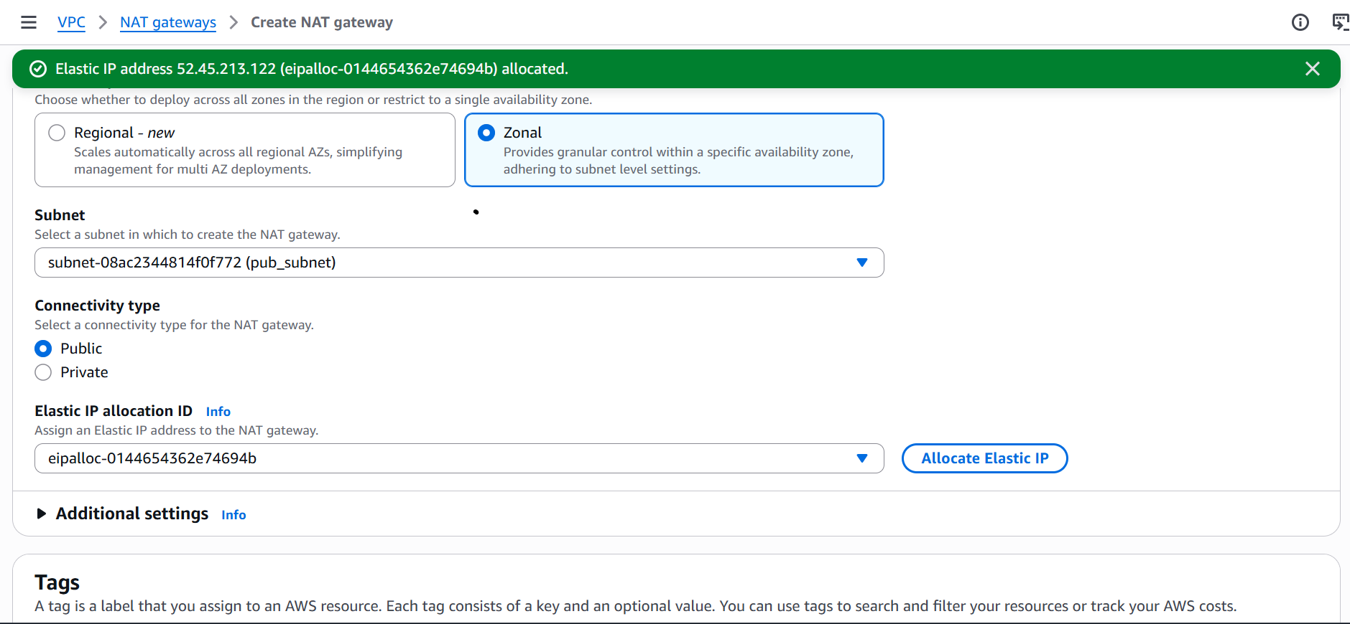

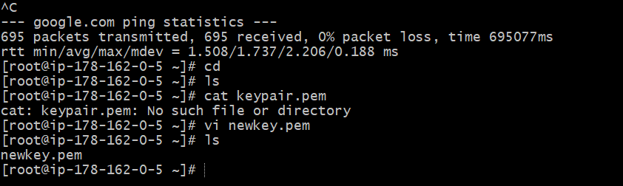
Now to connect to private instance from public instance
I have attached NAT gateway to public subnet and logged in to pub inst now I have copied keypair for private instance to the current location and now I will be connecting to private inst from current instance

Now I will be allowing NAT GATEWAY route in private subnet ROUTE TABLE
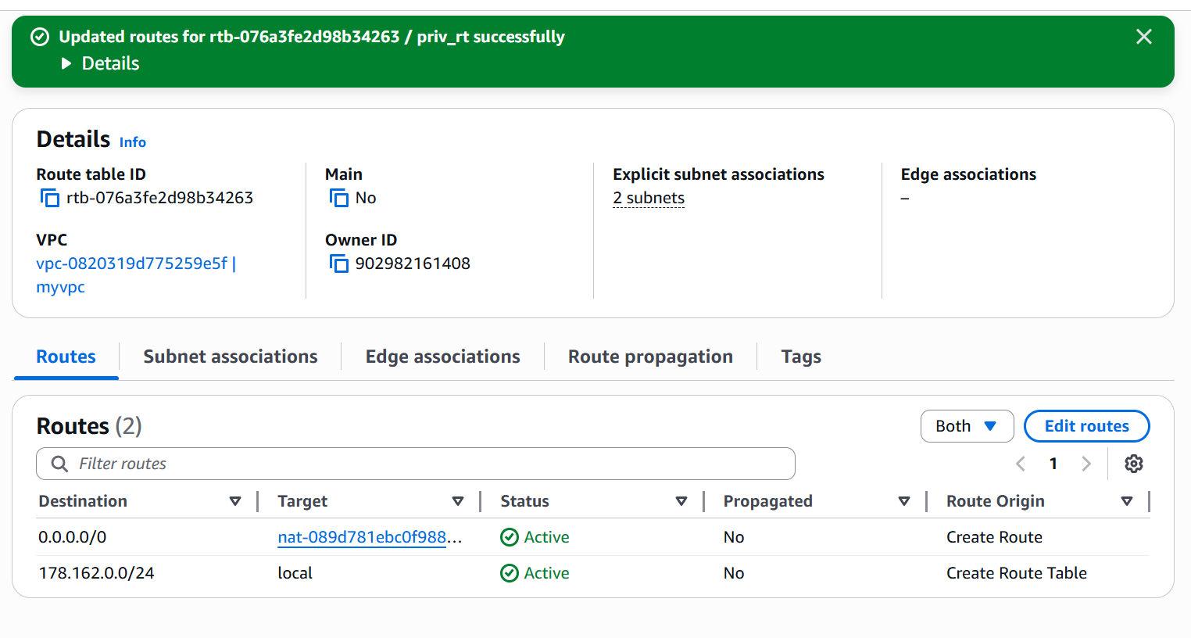

Here I have allowed NAT GATEWAY IN RT
And from the public instance I have logged into private instance using priv inst PRIVATE IP

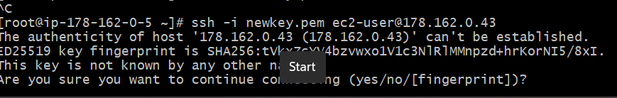

Install Apache Tomcat in private EC2 and deploy a sample app

I will launching a new app in private instance connecting from public instance via NAT GATEWAY
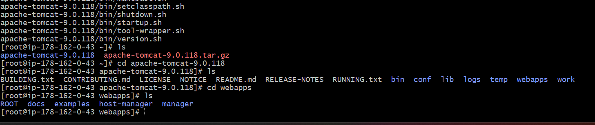

I have installed tomcat in private instance using wget

And now I will be deploying a sample app in tomcat

I will be installing java for tomcat 9 and deploying a sample war file in webapps

Configure VPC flow logs and store the logs in S3 and Cloud Watch

First I will be creating a new flow log for vpc to store log history
And we can store it in either s3 or cloudwatch
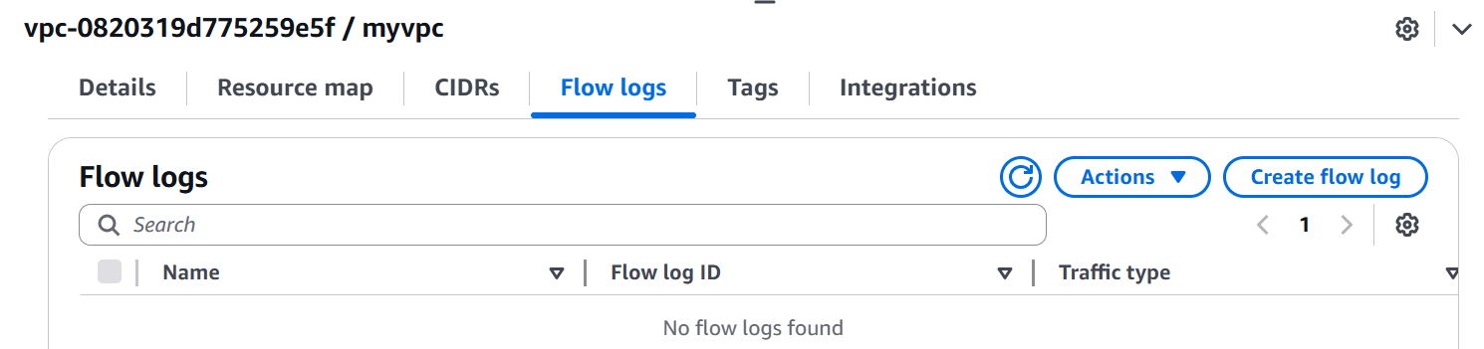

I have created a new flow log and it will be store in s3 bucket
And in creation of log-file gave my s3 bucket amazon name
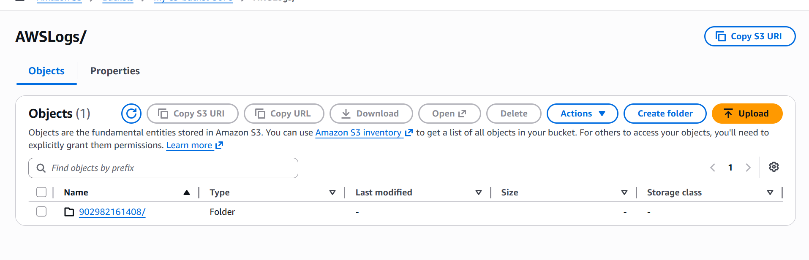
Now whatever changes I have done it will be stored in flow-logs
And can be downloaded from s3 bucket

Now I will be creating an iam role and permissions for cloudwatch and storing logs in cloud watch

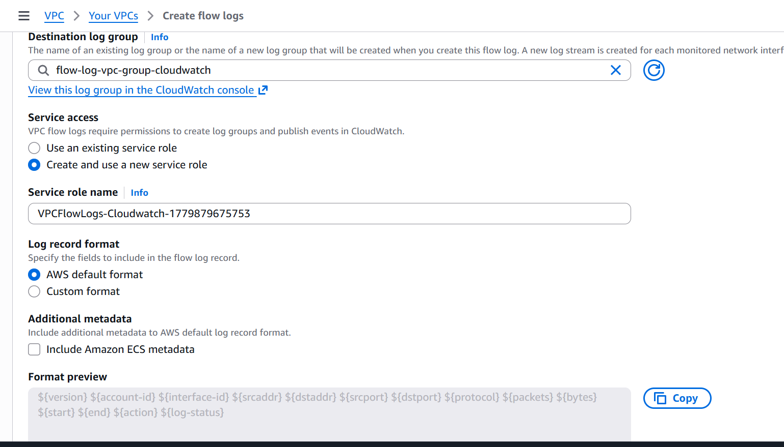

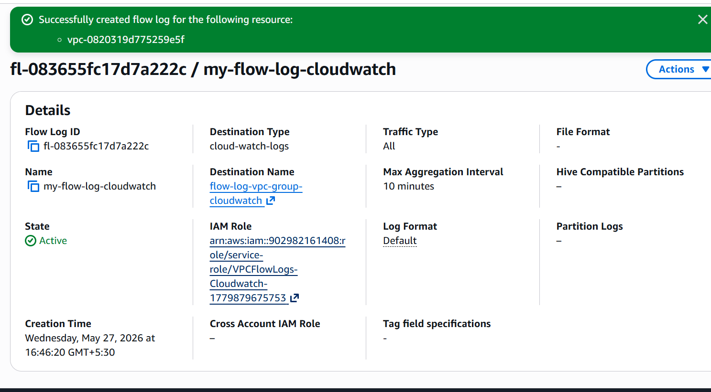

Succesfully created a cloudwatch log file
Now the changes made in vpc will be stored in both s3 and cloud watch

